# Intern Details

Name: Soniya Nanwani

College: Walchand College of Engineering

Roll No. : IJ250013

Project link: [Itssonia7/ev-battery-swap-booking-system: Web project to book EV battery swap appointments using Flask](https://github.com/Itssonia7/ev-battery-swap-booking-system)

# Web Development Project Report

Project Title: EV Battery Swap Appointment Booking System

## 1. Introduction

This web application allows users to register, log in, and book appointments to swap EV batteries at selected stations. It also features an admin panel to manage users and bookings. The project is built using Python Flask, HTML, CSS, and SQLite.

## 2. Objective

- To build a responsive EV appointment booking system  
- To implement secure user registration and login  
- To manage bookings by users and provide an admin dashboard

## 3. Tools and Technologies Used

- Programming Languages: Python, HTML, CSS  
- Frameworks: Flask  
- Database: SQLite (via SQLAlchemy)  
- Authentication: Flask-Login  
- IDE: Visual Studio Code

## 4. System Requirements

- Python 3.x installed  
- Flask and required libraries installed  
- Web browser (Chrome/Firefox)  
- SQLite browser (optional for viewing database)

## 5. Project Modules / Features

- User Registration and Login (hashed passwords)  
- Appointment Booking (station, date, time)  
- Flash messages for user feedback  
- Admin Login (hardcoded credentials)  
- Admin Dashboard: view all users and bookings

## 6. Project Flow / Working

1. New users sign up and log in.  
2. Authenticated users can book appointments.  
3. Bookings are saved and linked to the logged-in user.  
4. Admin logs in separately to view all bookings and users.  
5. Flash messages give success/error updates.  
6. The app uses session management to handle login states.

## 7. Output Screenshots

Provided at the end of this document

## 8. Testing and Evaluation

- Manual testing performed for login, signup, and booking functionality.  
- Verified flash message alerts and admin dashboard data visibility.  
- Tested layout responsiveness on different screen sizes.

## 9. Conclusion

This project helped in understanding Flask backend structure, session handling, database modeling, and frontend development. The app is user-friendly and functions well locally.

## 10. Acknowledgment

I would like to thank my faculty, mentors, and project guides for their valuable guidance and support.

## 11. References

- Flask Documentation  
- W3Schools  
- MDN Web Docs  
- Stack Overflow

## 7. Output Screenshots

### Home Page

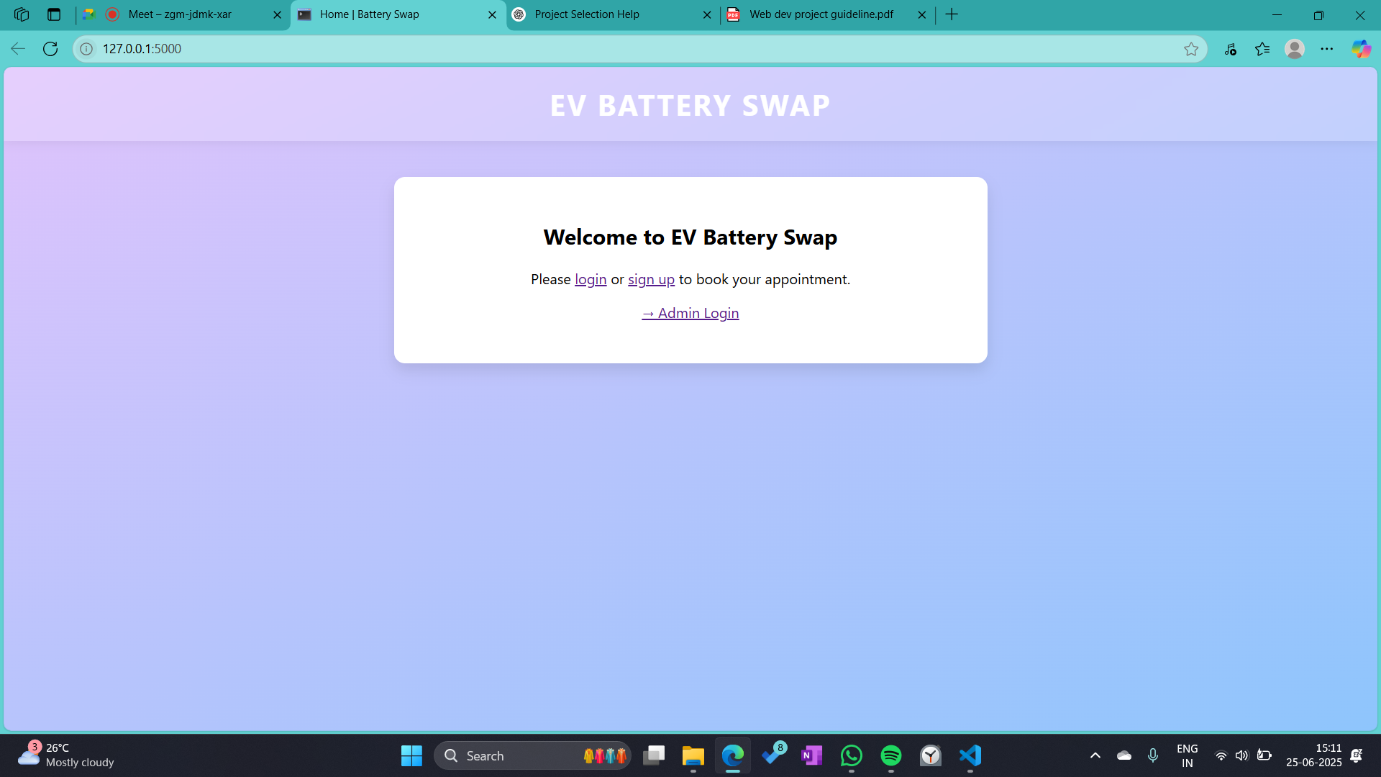

### Login Page

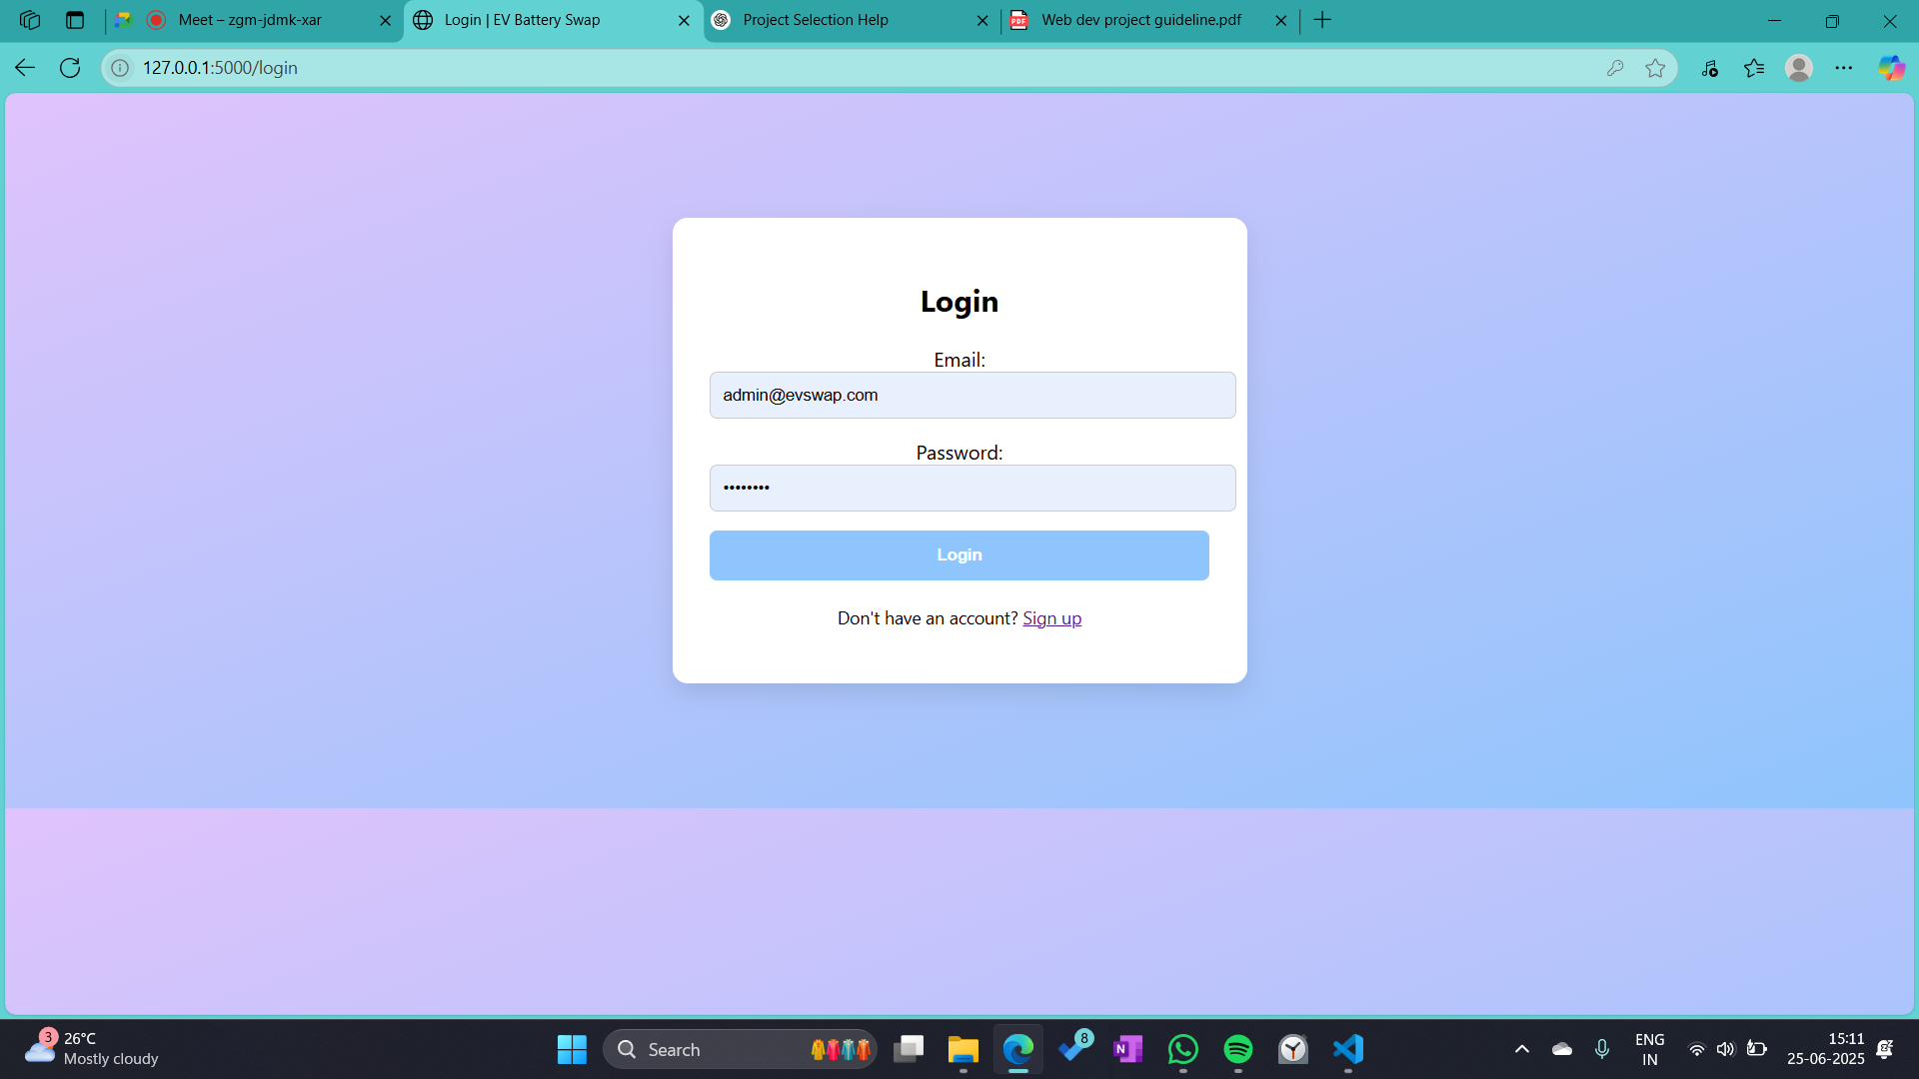

### Signup Page

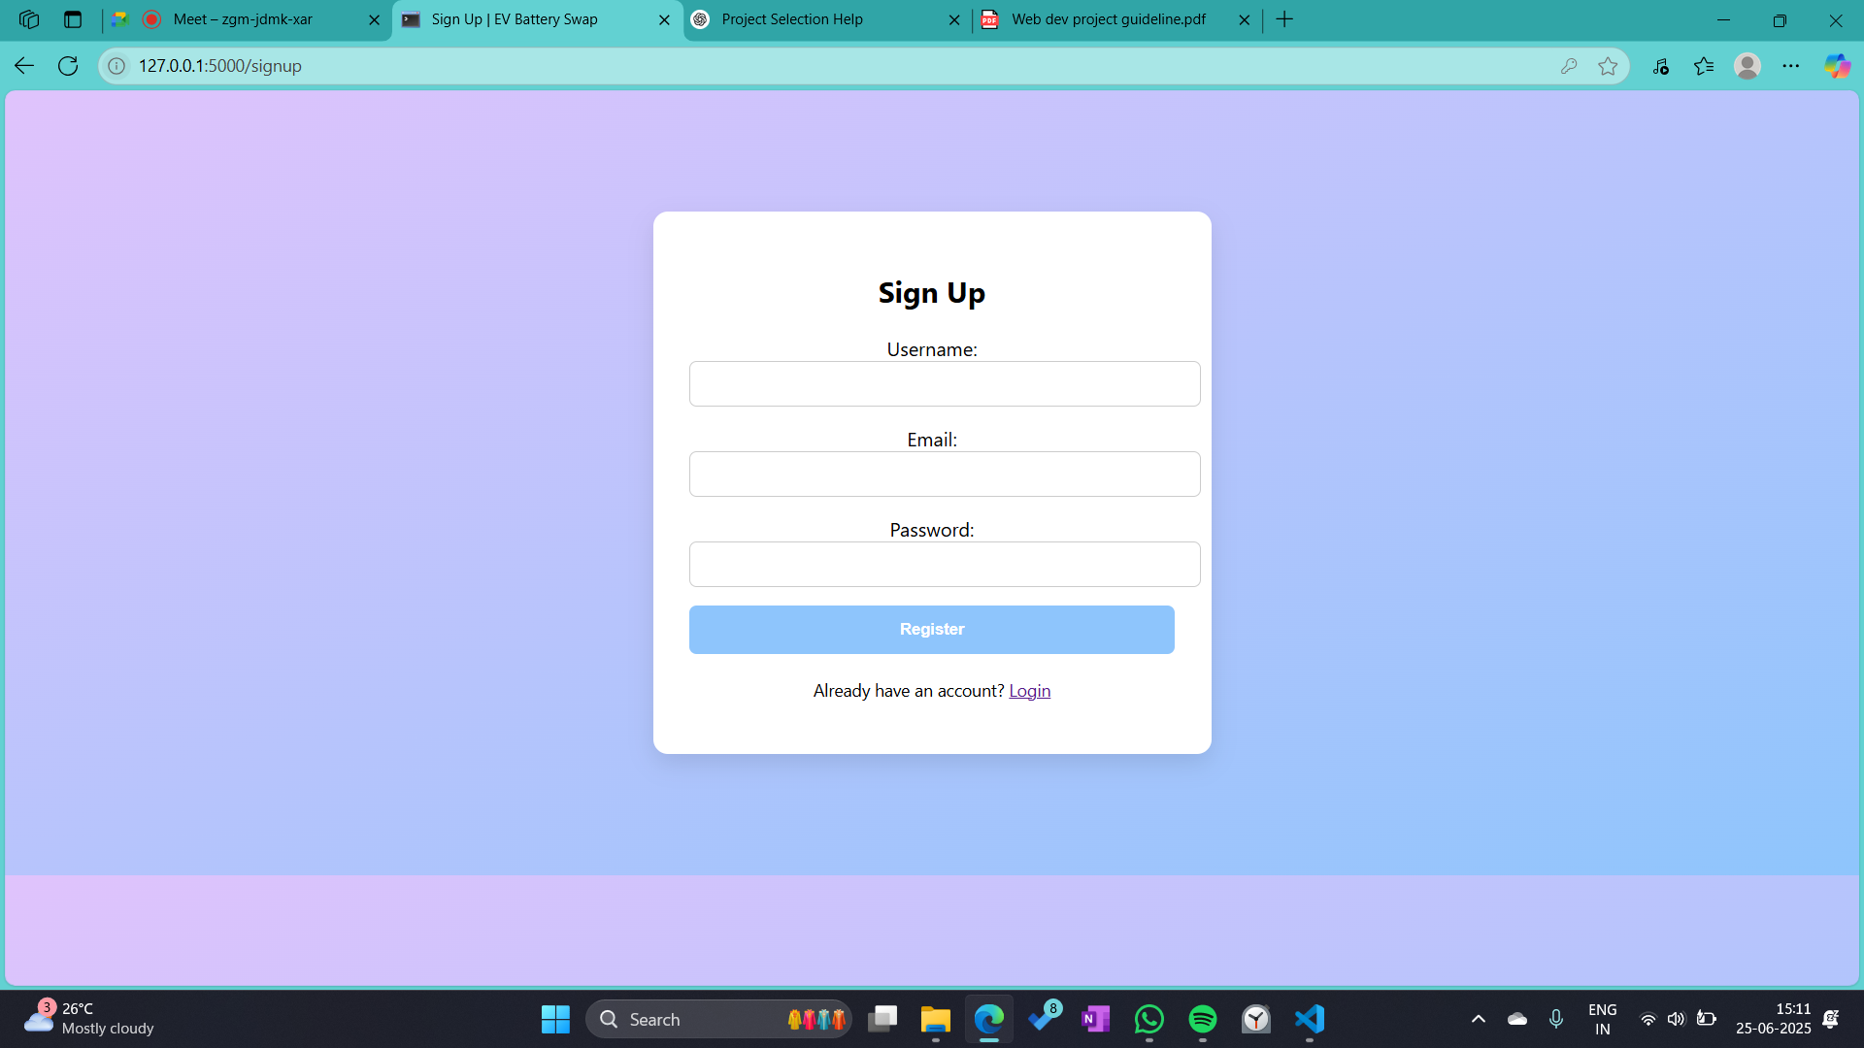

### Admin Login

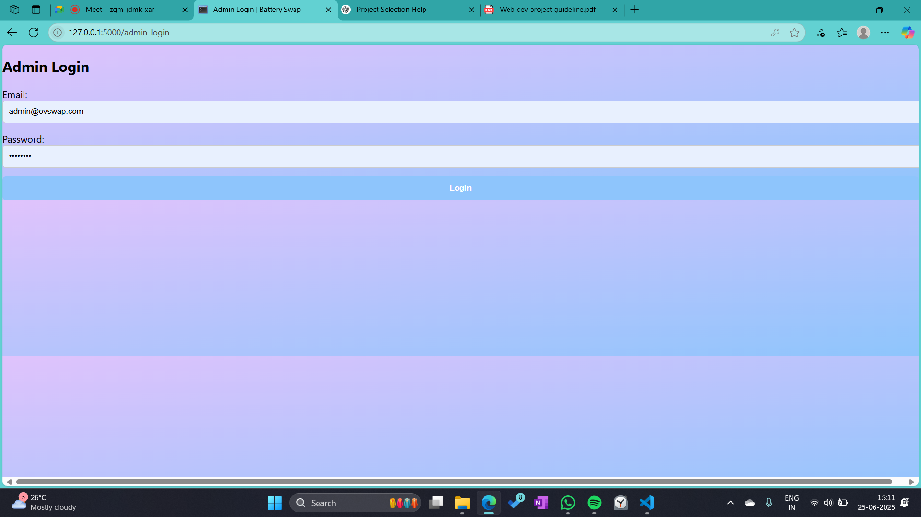

### Admin Dashboard

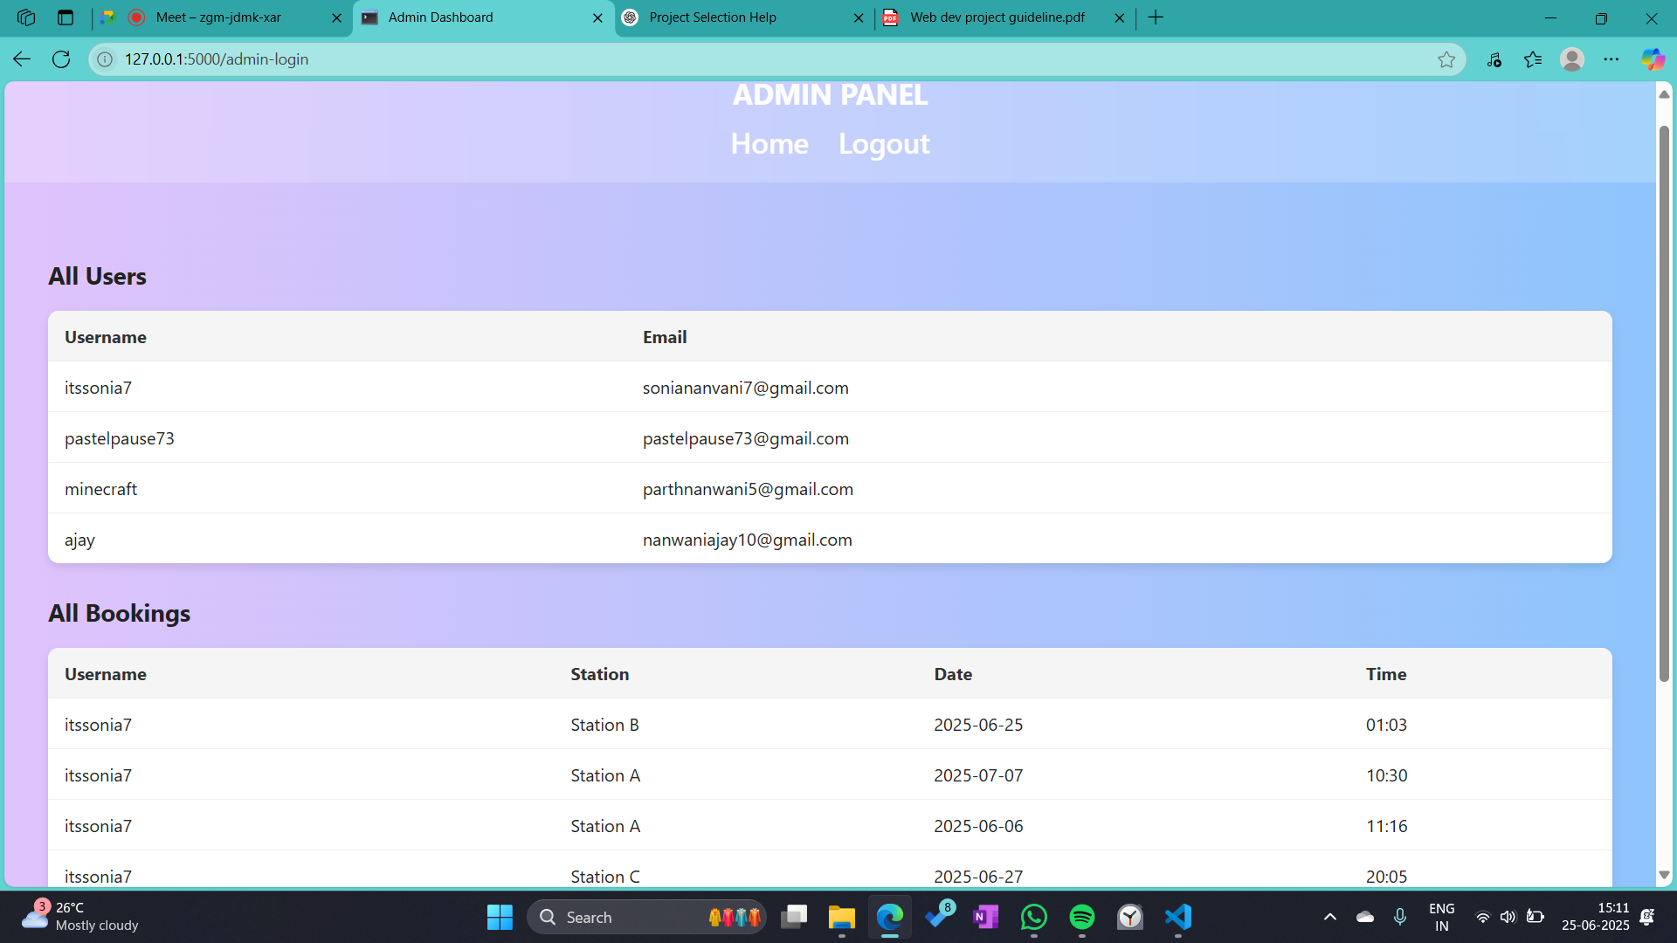

### User Dashboard

